# How to start with Chrome and Teamviewer.

Ask the user to bring up the “Chrome Browser” on her machine. If she can’t do it, see if Chrome is on the machine. It might be on the desktop, or on the toolbar. If not click the Start button on the lower left. It may be on the menu that pops up. If not, type “Chrome” into the “Search programs and files “ Text Box. When you find the icon, double-click it.

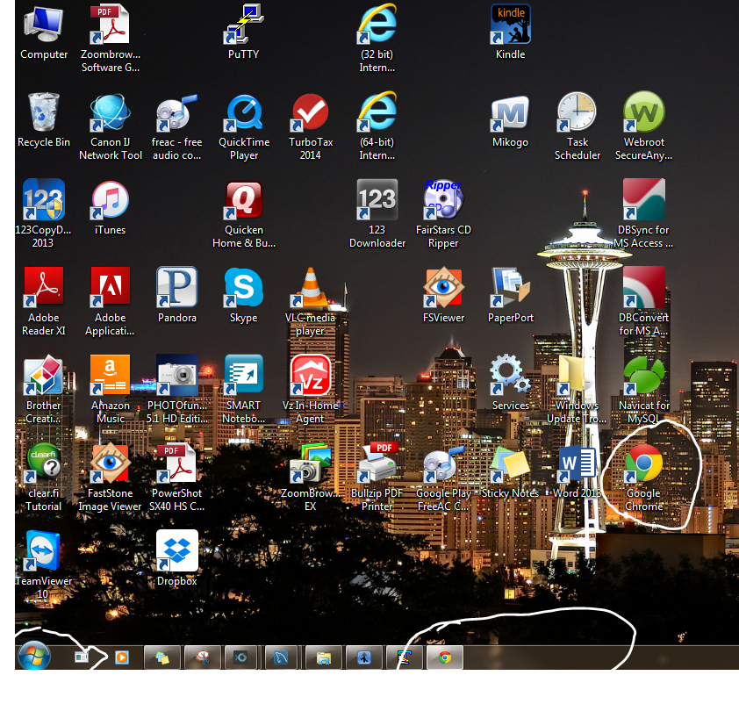

If you can’t find Chrome, install it by using whatever browser she has (probably Internet Explorer) to download Chrome, by going to Google, and searching for “Download Chrome”. Click on “Go to download”. Click the download button, etc.

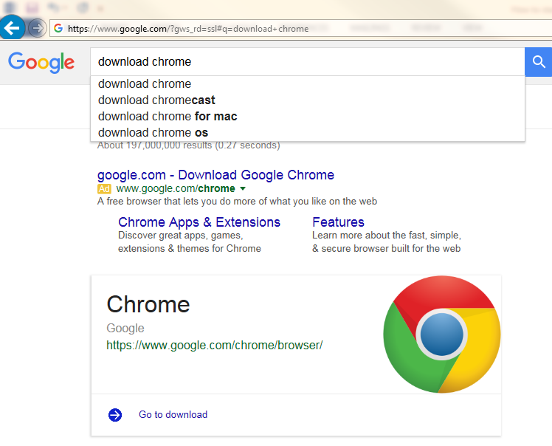

Click the “Download Chrome” button, and follow the prompts, etc

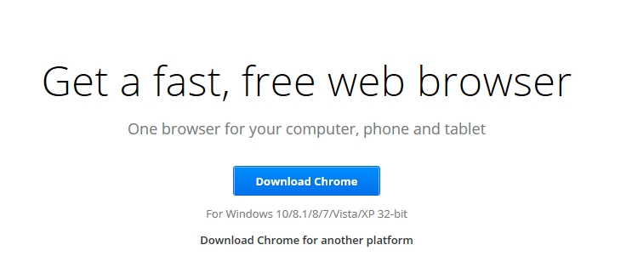

After you get Chrome up, you want to install a bookmark to our site. Type **test.uisdesign.com** into the url box. 

When you hit return, the login box for LTWeb comes up.

Hit **ctrl-d** right then to create the bookmark. Say that you want it to be on the Bookmarks Toolbar.

The last step is to be sure the Bookmarks Toolbar is always visible. Do this by selecting the **Chrome Options** button (circled above). Then click on **Settings**, and then check **Always show the bookmarks bar**.

Then close the Settings tab (circled).

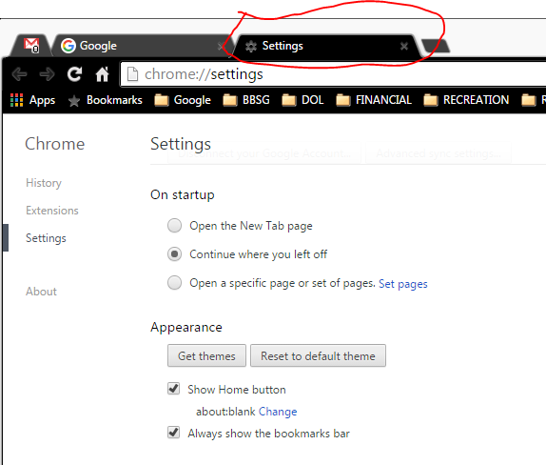

To install Teamviewer, browse to **teamviewer.com.** Click on **Download Free for private use.**

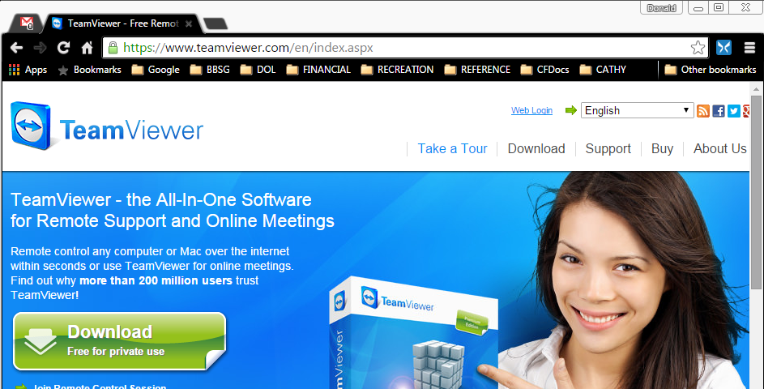

This will download a file. **Open the file** to start the installation, and follow the prompts. This can take up to ten minutes to finish.